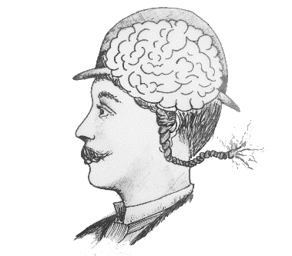
MIND-BOGGLING MEDICAL HISTORY
EVALUATION FORM

- Which of the following best describes you? (You can choose more than one option).

School teacher | University or  college lecturer | Museum  staff
School student | University or college  student | Museum  visitor
Other (please specify):

If you are a teacher or lecturer, in which subject: ____________________________

- Did you use the game to fulfil specific learning objectives? YES NO

If yes, please say what they were:

- Did the game meet these objectives? (please circle and explain below)
YES NO PARTIALLY

TURN OVER

- Did you use the additional teaching resources featured on the Mind-Boggling Medical History website?
Yes No
If Yes, list which ones:

- Are there any ways that you think we could improve the game?

- Any other comments on the game or teaching resources?

THANK YOU FOR PLAYING MIND-BOGGLING MEDICAL HISTORY!

